

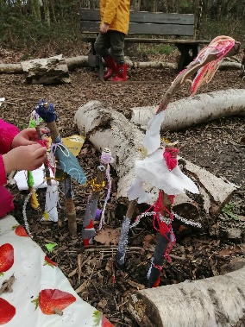
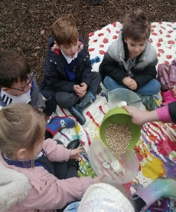
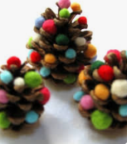
Creating a ‘Forest Friend’.
Sustainability
Making natural bird feeders to hang in the trees.
Make woodland Christmas decorations.
EYFS Outdoor Learning Journey
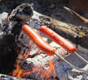
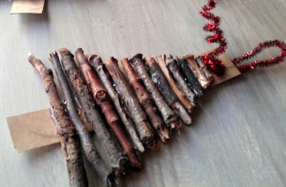
AUTUMN 1

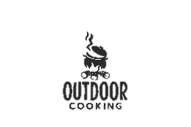
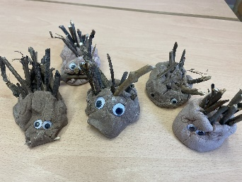

Make a woodland animal
Using natural objects collected from the woodland.


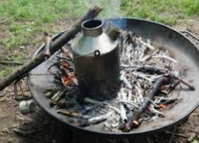
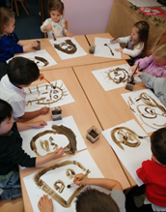

Outdoor Cooking -Hot dogs.


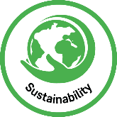
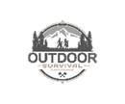

AUTUMN 2
Natural Art Collecting mud and creating own mud paint to create a self-portrait.
Outdoor Cooking – Santa’s Hot chocolate.
SPRING 1

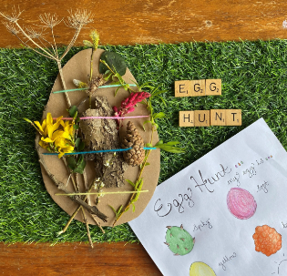
Texture Hunt
Explore the environment to find something smooth, hard, rough, spiky, bumpy and soft to decorate your Easter egg, using your senses to describe each texture.
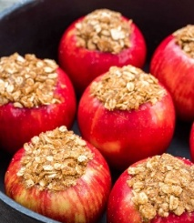
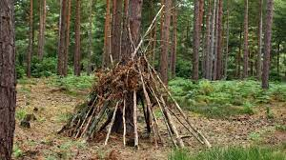
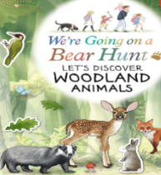

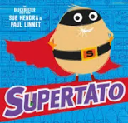

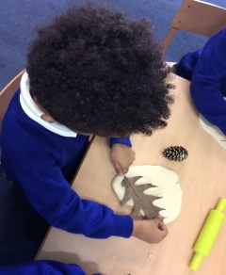

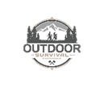

Obstacle Course
Children will work collaboratively to design and create an obstacle course inspired by Supertato, then challenge themselves to complete it using different movements and skills.
Outdoor Survival Skills
Den and shelter building using communication and collaboration.
Outdoor cooking
Baked apples filled with oats and a sprinkle of brown sugar
Outdoor Art Printing with natural resources.
Woodland Animal Hunt
Read We’re Going on a Woodland Animal Hunt, then follow the clues and discover hidden woodland animals along the way

