Subject | Autumn 1 | Autumn 2 | Spring 1 |  |  | Spring 2 | Summer 1 | Summer 2
Our INTENT
INTENT

CORE VALUE | WE ARE KIND | WE ARE SAFE | WE ARE RESILIENT |  |  | WE ARE ACCEPTING OF DIVERSITY | WE ARE RESPECTFUL | WE ARE TALENTED
TOPIC DRIVER | Understanding the World | Understanding the World | DT |  |  | Understanding the World | Understanding the World | Expressive Arts and Design
EYFS THEMES & DRIVERS | Marvellous Me! | Everyone is a Hero | Animal Adventure |  |  | Ready, Steady, Grow | Fantasy Worlds | Life Is an Adventure
TALK FOR WRITING | Nursery  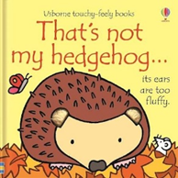 | Nursery  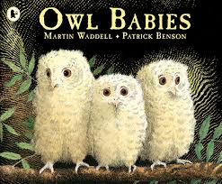 | Nursery  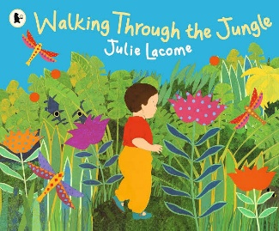 |  |  | Nursery  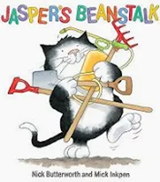 | Nursery  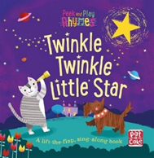 | Nursery  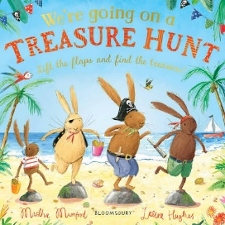
TALK FOR WRITING | Reception  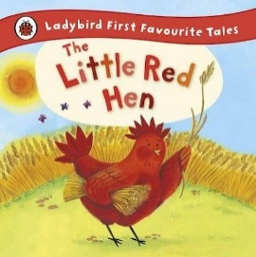 | 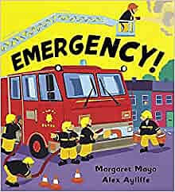  Reception | Reception  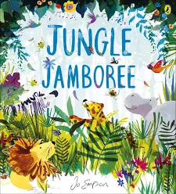 |  |  | Reception  The Sleepy  Bumble Bee - Pie Corbett | Reception  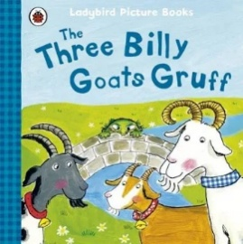 | Reception  The Story or Pirate Tom – Pie Corbett
TALK FOR WRITING | Non – Fiction  Instruction writing | Non – Fiction  Poem | Non – Fiction  Information writing |  |  | Non – Fiction  Fact File | Non – Fiction  Wanted Poster | Non – Fiction  Fact File
PIE CORBETT  READING SPINE | Nursery |  |  | Reception
PIE CORBETT  READING SPINE | 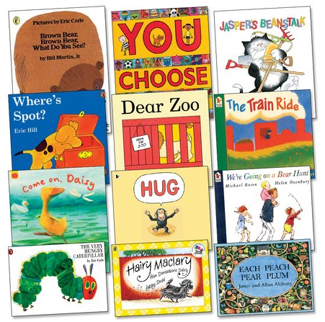 |  |  | 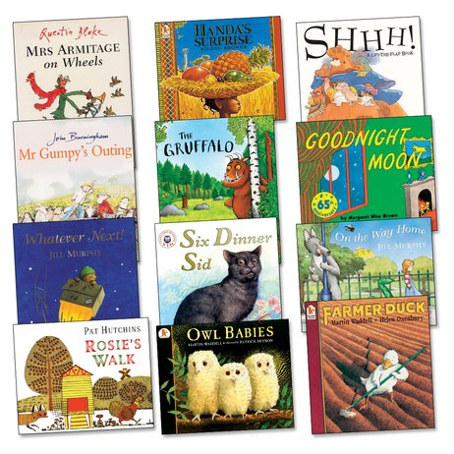
MATHS | Nursery |  |  | Reception
MATHS | 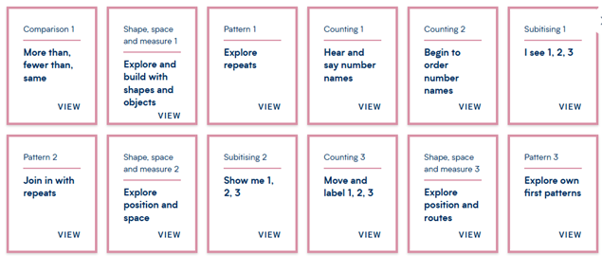  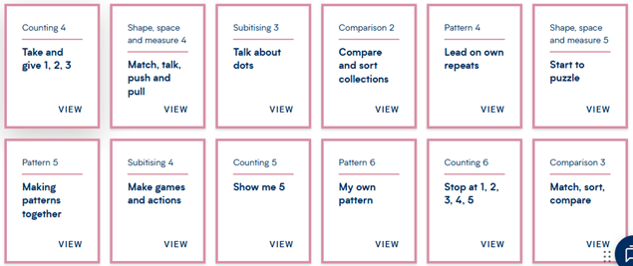 |  |  | 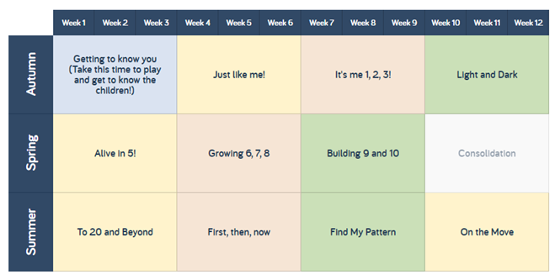
PHONICS | Set 1 Sounds (Group B by the end of term)  Read all single letter sounds speedily – 25 sounds.  Use ‘Fred Talk’ to orally blend  Whiteboards and single letter sounds are used to support reading routine | Set 1 sounds (Group C by the end of term)  Read single letter sounds speedily and become confident with oral blending  Spell with Fred fingers | Ditty  Begin teaching ‘Special Friends’ and 3 sound nonsense words  Spell with Fred fingers  Begin reading Ditty’s |  |  | Ditty  Begin teaching ‘Special Friends’ and 3 sound nonsense words  Spell with Fred fingers  Begin reading Ditty’s  Red  Review Set sounds.  Read 4/5 sound words  Spell with Fred fingers  Begin story books  Get Writing books | Red  Review Set sounds.  Read 4/5 sound words  Spell with Fred fingers  Begin story books  Get Writing books  Green  Teach Set 2 sounds  Build speed reading nonsense words  Spell with Fred Fingers  Teach the first size Set 2 sounds  Read Green story books  Get Writing books | Green  Teach Set 2 sounds  Build speed reading nonsense words  Spell with Fred Fingers  Teach the first size Set 2 sounds  Read Green story books  Purple  Read 37 sounds speedily  Spell with Fred fingers  Read Purple story books
 | LINKS TO CURRICULUM
LINKS TO SUBJECT DRIVER | Understanding the World  - Who is in my family?  - Where in the world do I live?  - What are my senses?  - Seasons  - Signs of Autumn  - Changes in weather | Understanding the World  - How do we celebrate (Birthdays, Diwali, Bonfire night, Christmas)  - Celebrations differ in communities  - Talking about different roles (Police, Doctors, Vets) | DT  - Animal junk models |  |  | Understanding the World  - Animal life cycle  - Plant life cycle  - Contrasting seasons  - Able to talk about the care of living things  - How does animals grow? | Understanding the World  - Does your parent know the same nursery rhyme as you?  - What is the weather like today? | Expressive Arts and Design  PSED  - What is a country?  - Are there different countries?  - Transition to Rec/KS1  - Looking back on the year
EXPRESSIVE ARTS AND DESIGN | Drawing  - Explain and talk about the marks made  - Use a mirror and draw my face and features | Painting  - Explore the use of poster paint  - Explore primary colours  - Colour mixing with the primary colours  - Painting using different tools  - Painting on different surfaces | 3D Sculptures  - Junk box model making  - Consider and plan a final outcome  - Use tools appropriately (scissors/modelling tools) |  |  | Printing  - Print with a variety of objects and colours  - Explore how different objects create different prints | Collage  - Enjoy using and explore different materials  - Use appropriate language to describe material | Textiles  - Threading a needing  - Simple weaving  - Simple sewing stitch
RE | Celebration of Rosh -  Hashanah  Judaism | Celebration of Diwali  Hinduism/Sikhism  Christianity | Celebration of Chinese New Year  Various |  |  | Celebration of Easter  Christianity | Celebration of Eid  Muslim | Celebration of Dharma  Buddhism
ONE LIFE | 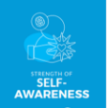 | 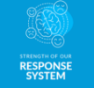 |  |  |  |  |  | 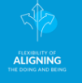
 | PLAY AND PROVOCATIONS
PROVISON AND PROVOCATIONS | Dramatic Play  - Home corner | Dramatic Play  - Home corner – enhanced  - Hospital | Dramatic Play  - Travel Agents |  |  | Dramatic Play  - Minibeast  - Investigations | Dramatic play  Garden centre  - Little Red Riding Hood – Grandma’s cottage | Dramatic Play  - Pirate Ship
PROVISON AND PROVOCATIONS | Small World  - Town and city  - Local area, roads and transport, houses and people  - Doll’s house for home life | Small World  - Diverse characters  - Different celebrations Police station  - Hospital | Small World  - Animals from around the world |  |  | Small World  - Minibeast investigation area  - Real life cycle  - Minibeasts in our school area | Small World  - Little Red Riding Hood’s cottage | Small World  - Pirates  - Dinosaurs
PROVISON AND PROVOCATIONS | Understanding the World  - Maps, plans, photos of the local area. | Understanding the World  - Autumn area Diwali  - Festivals- bonfire night, Halloween, Christmas | Understanding the World  - Recycling area – why do we recycle?  - Celebrating Chinese New Year |  |  | Understanding the World  - Comparing different environments  - Thinking about pollution and recycling  - Learning about the Christian celebration of Easter | Understanding the World  - Life cycles – Ducks/frogs  - Plant life cycle | Understanding the World  - How do we stay healthy?  - Looking after our teeth  - Comparing two contrasting environments  - Experiment with floating and sinking
EXPRESSIVE ARTS AND DESIGN IN THE CLASSROOM | Creating with Materials  Draw and paint using a range of materials, tools and techniques, experimenting  with colour, design, texture, form and function; | Creating with Materials  Draw and paint using a range of materials, tools and techniques, experimenting  with colour, design, texture, form and function; | Creating with Materials  Draw and paint using a range of materials, tools and techniques, experimenting  with colour, design, texture, form and function; |  |  | Creating with Materials  Draw and paint using a range of materials, tools and techniques, experimenting  with colour, design, texture, form and function; | Creating with Materials  Draw and paint using a range of materials, tools and techniques, experimenting  with colour, design, texture, form and function; | Creating with Materials  Draw and paint using a range of materials, tools and techniques, experimenting  with colour, design, texture, form and function;
EXPRESSIVE ARTS AND DESIGN IN THE CLASSROOM | Marker skills – lines & detail  Self portrait  Family picture  House picture  Add Watercolours to sketches to develop pictures from Autumn | Draw and Paint  A picture of people who keep us safe. Large and small brushes using poster paint.  Natural world:  Mixing colours- Autumn changes and leave printing | D&T design and make a junk box model independently (design, texture, form and function)  Pencil Progression – adding detail to drawings and different ways of using a pencil, for example shading. |  |  | Pencil:  Looking at how people look different.  Different resources to create patterns (cotton buds, sponges etc) | Pencil and Water colours – observational drawings of animals and Spring flowers/plants  Collage –  Collage of plants and animals  Life cycle collage | Clay – Linked to healthy bodies – fruit/vegetables  Textiles – stitching, puppet, materials
OUR CHILDREN AS POETS | Nursery
OUR CHILDREN AS POETS | Humpty Dumpty  Row, Row, Row your Boat  I’m a Little Teapot  Little Miss Muffett  Hey Diddle Diddle  Old Macdonald Had A Farm  Heads, Shoulders, Knees and Toes  One, Two, Buckle my Shoe | Rain, Rain Go Away  The Little Kittens  The Wheels on the Bus  Little Boy Blue  1,2,3,4,5 Once I Caught A Fish Alive  Pat A Cake  Jack and Jill | Little Bo Peep  Little Jack Horner  Old Mother Hubbard  Sing a Song of Sixpence  I hear Thunder  Ring a Ring A Roses |  |  | Mary had A Little Lamb  Hickory Dickory Dock  It’s Raining, It’s Pouring  Hot Cross Buns  Jack be Nimble | There Was An Old Woman  Twinkle, Twinkle, Little Star  Wee Willie Winkie  The Grand Old Duke of York  Polly Put The Kettle On |  |  | Mary, Mary Quite Contrary  Please Porridge Hot  Three Blind Mice  London Bridge is Falling Down  Oranges and Lemons  If you’re Happy and You Know It  Pop Goes The Weasel
OUR CHILDREN AS POETS | Reception
OUR CHILDREN AS POETS | Whizz Around the Playground  Amazing Me | Shiny Moon  Nights Fright  Too Hot Chocolate | Try a Smile  Brum Brum  Pancake Rap |  |  | Hatching  Shiny Snail  Beautiful Butterfly | Here’s A Box  Noisy Farm  Noisy Farm  Wiggly Worm |  |  | Sports Day  Monster Crunch  Time to Shine  Very Hot Today
CELEBRATIONS THIS YEAR | Autumn  October  Halloween  November  Diwali  Remembrance Day  December  Advent  Christmas |  | Spring  January  Chinese New-Year  February  Shrove Tuesday  Lent  March  Mother’s Day  St. Patricks Day  Easter  April  St. George’s Day |  |  |  | Summer  June  Father’s Day
VISTS/  EXPERIENCES | Autumn walk  (local around school) | Nativity | Junk model exhibition People who help us day |  | Spring walk around the school grounds  Duck eggs |  | Fairy Tale Day |  | Sports Day

